附件一：研究生英文学位证明模板
1、学科专业名称请以附件二：中英文对照表为准；
2、根据中文证书内容，把模板中红色部分填写完整，去掉括号内容后自行打印（实例请参见第2、3页），本人或委托他人携带相关证件至主楼212审核盖章即可。
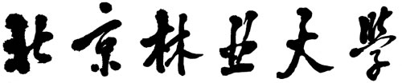
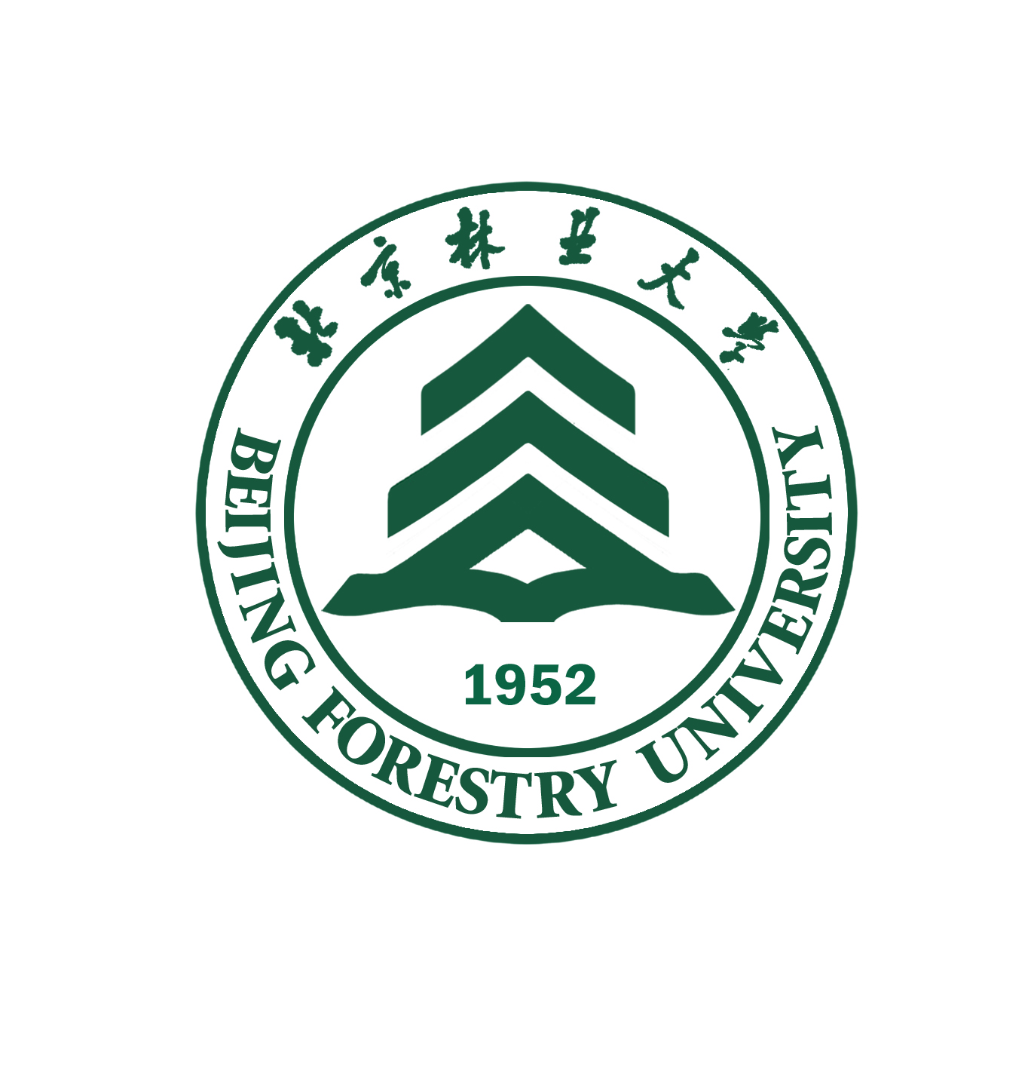
BEIJING FORESTRY UNIVERSITY

MASTER（按实际学位填写）’S DEGREE CERTIFICATE
×××（姓名）, Male or Female（性别）, born on Apr. 26, 1985（出生日期）, has completed prescribed 3（与毕业证一致）-year courses with the major of Landscape Architecture（专业）. She or He is granted graduation. As assessed in accordance with the Academic Degree Regulations of the People’s Republic of China, the student is hereby awarded the Master of Engineering（学位类型）.

President of Degree Appraising Committee: Mr. ×××（校长名）
Registered Certificate No.: ×××（填写学位证书编号 100223……开头）
July 24, 2021（发证日期）

硕士实例：
BEIJING FORESTRY UNIVERSITY

MASTER’S DEGREE CERTIFICATE
Zhang San, Female, born on Apr. 26, 1985, has completed prescribed 3-year courses with the major of Landscape Architecture. She is granted graduation. As assessed in accordance with the Academic Degree Regulations of the People’s Republic of China, the student is hereby awarded the Master of Engineering.

President of Degree Appraising Committee: Mr. An Lizhe
Registered Certificate No.: 100223xxxxxxxxxx
July 24, 2021

博士实例：
BEIJING FORESTRY UNIVERSITY

DOCTOR’S DEGREE CERTIFICATE
Zhang San, Female, born on Apr. 26, 1985, has completed prescribed 3-year courses with the major of Landscape Architecture. She is granted graduation. As assessed in accordance with the Academic Degree Regulations of the People’s Republic of China, the student is hereby awarded the Doctor of Engineering.

President of Degree Appraising Committee: Mr. An Lizhe
Registered Certificate No.: 100222xxxxxxxxxx
July 24, 2021

